**LIMITS ON DIFFERENCE AMPLIFIER**

**INA143**

Input to 4 analog connectors, each receiving up to 2 differential inputs: +- 15V

Rsense must be chosen that I drawn isn’t too high, it is much lower than the RL load.

There should still be a discernible difference between V+ and V- terminals.

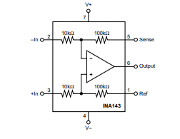

VREF = 2.048V is supplied from the AMDC and the 0.1 gain is set using the INA2143UA's internal resistors (laser trimmed during IC fab to create a precisely matched set).

V across Rsense= 2.5A (max high side current in one branch)* 0.5 ohm

VO = 10 (V3 – V2)max <= +15V

**Rsense is chosen as .5ohm.**

**MOSFET GATE DRIVER**

Vdrive for PWM outputs: 5V - 10V

For 100% duty cycle: input voltage to driver should be able to take up up 10V and off will be 0V.

An offset might be needed to make sure OFF state is still 1.35V

**UCC27537**

10V - 35V VDD

Low= 3.3V

High= 5.5V

0 V at input pin means driver is OFF>

independent of the VDD supply voltage

If EN is grounded then No output. EN can take upto 25V which means VDD can be connected to it for turn on.

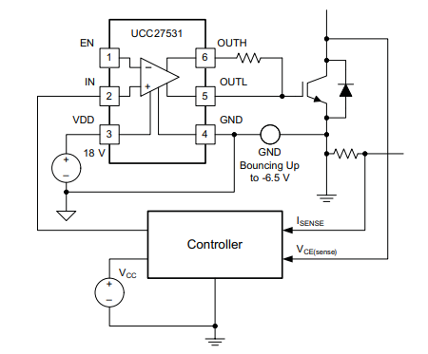

R between OUTH and OUTL is taken as 1ohm.

No extra components required besides VDD connection.

**LOAD CALCULATIONS:**

**The limit on resistive load in each branch is 4ohm.**

L(per branch) can be found based on power factor.

Active power (maximum) occurs at pf=1.

Pa = Vrms* Irms* pf = 7.071 * 1.77 *1 = 12.52W

cos-1(phi) = atan(Lw/R)

w= 2* pi* 10kHz (max frequency of the AMDC PWM)

L = 5 0uH